**Web Programming Assessment 2 Development document**

|  |  |
| --- | --- |
| **Student’s Name:** | Tallal Khan Tatari |
| **Id. No:** | 424030 |
| **Date of Submission** |  |
| **GitHub Repository Name:** |  |
| **GitHub Repository Link:** |  |
| **Website Link** |  |
| **Theme (Topic)** | Gaming: Genshin Impact |

Github Repository Screenshot:

**Brief**

This task was about choosing a specific theme and making a five-page website about it which uses the coding skills learned across the whole web programming course which includes HTML, CSS (to style the website) and Java Script (to add interactivity).

**DESIGN DIRECTION**

I chose games as my choice for the theme of my website as I thought it would be the most fun to make and they look the best due to all the videos and animation, my website is inspired from the PC/Mobile/console game called Genshin Impact which I love to play a lot and is the basis of design concept of my website along with my own added changes and inspirations. The website was made to give the user a full experience and information about the game by using videos and beautiful images from the game while still keeping the storyline and a lot of the gameplay hidden to make the user download the game and find out. The layout of the website was kept simple for easy navigation with a header at the top containing the logo and the buttons to go to the other pages, the main information at the center which contained a lot of multimedia such as videos and images from the game to truly showcase the beautiful graphics, maps and gameplay. A simple footer was made for the bottom with copyright information.

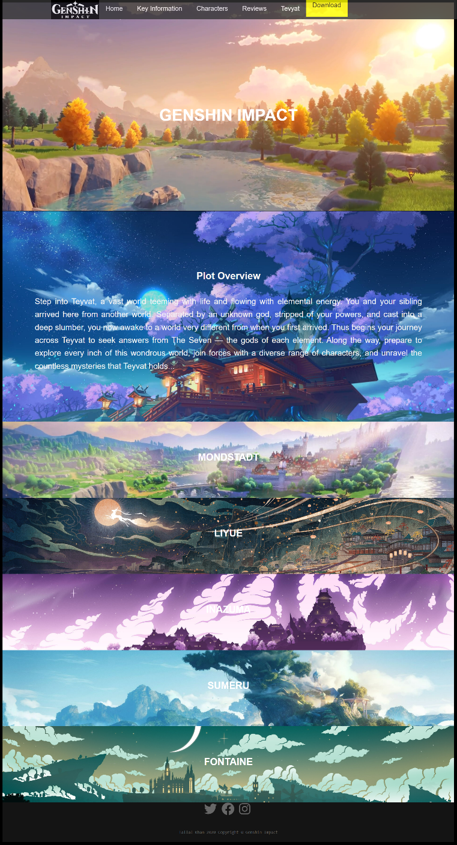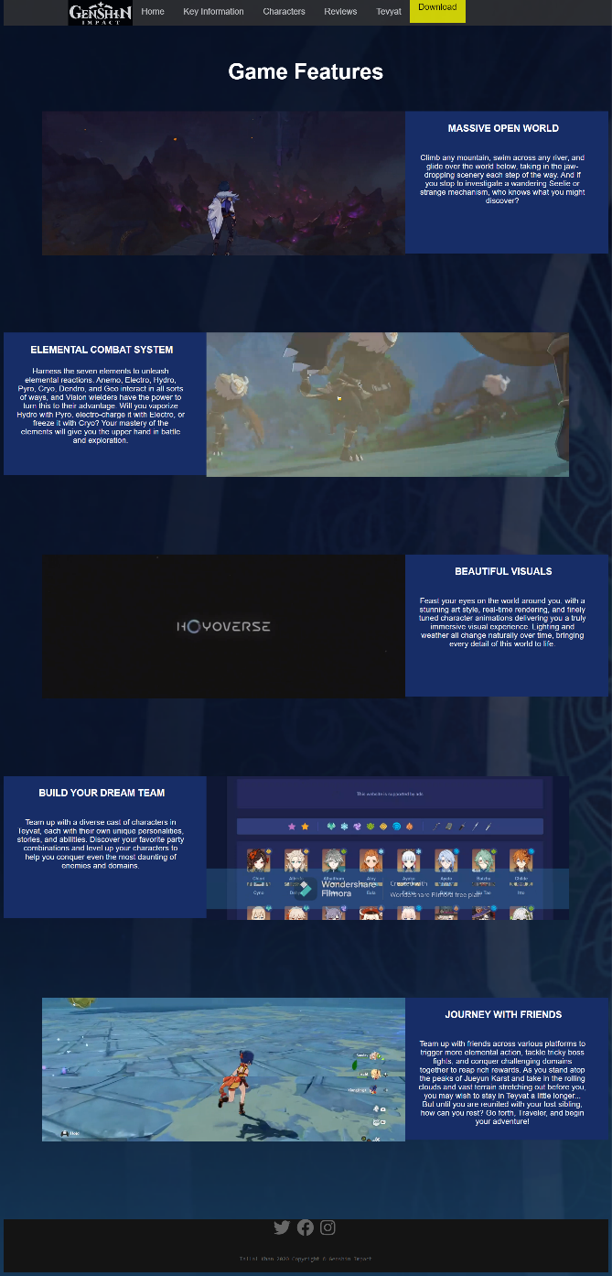

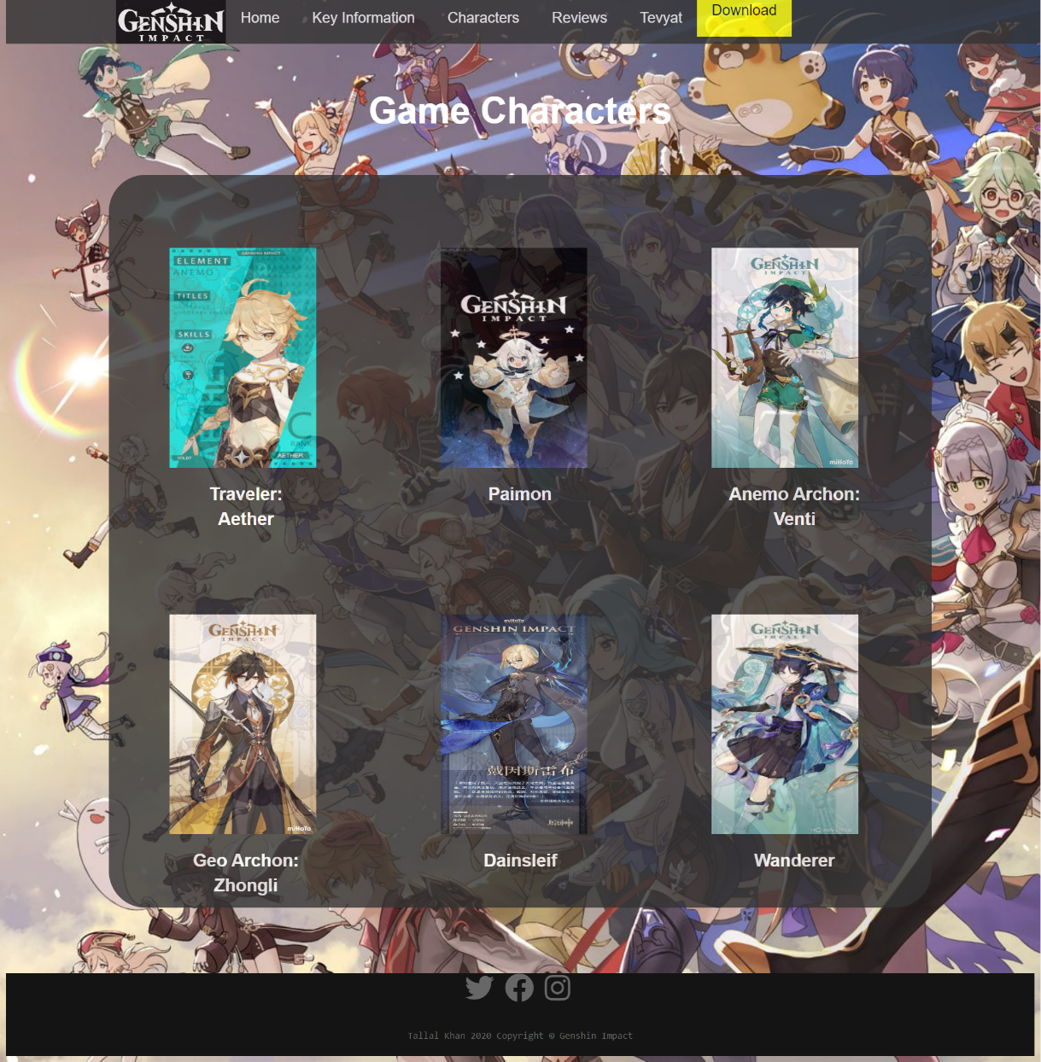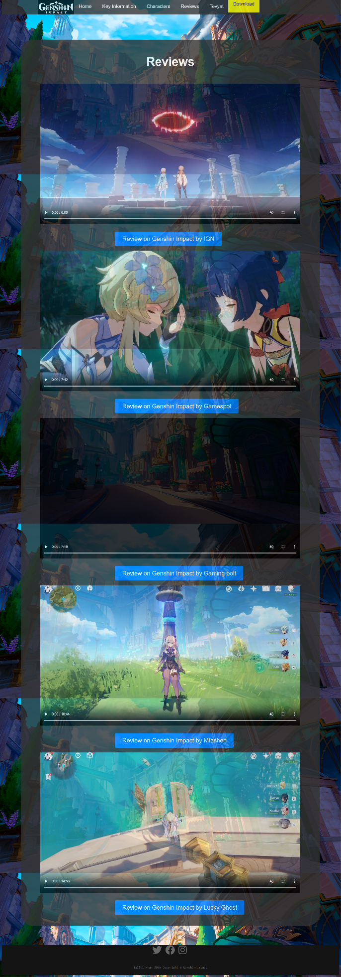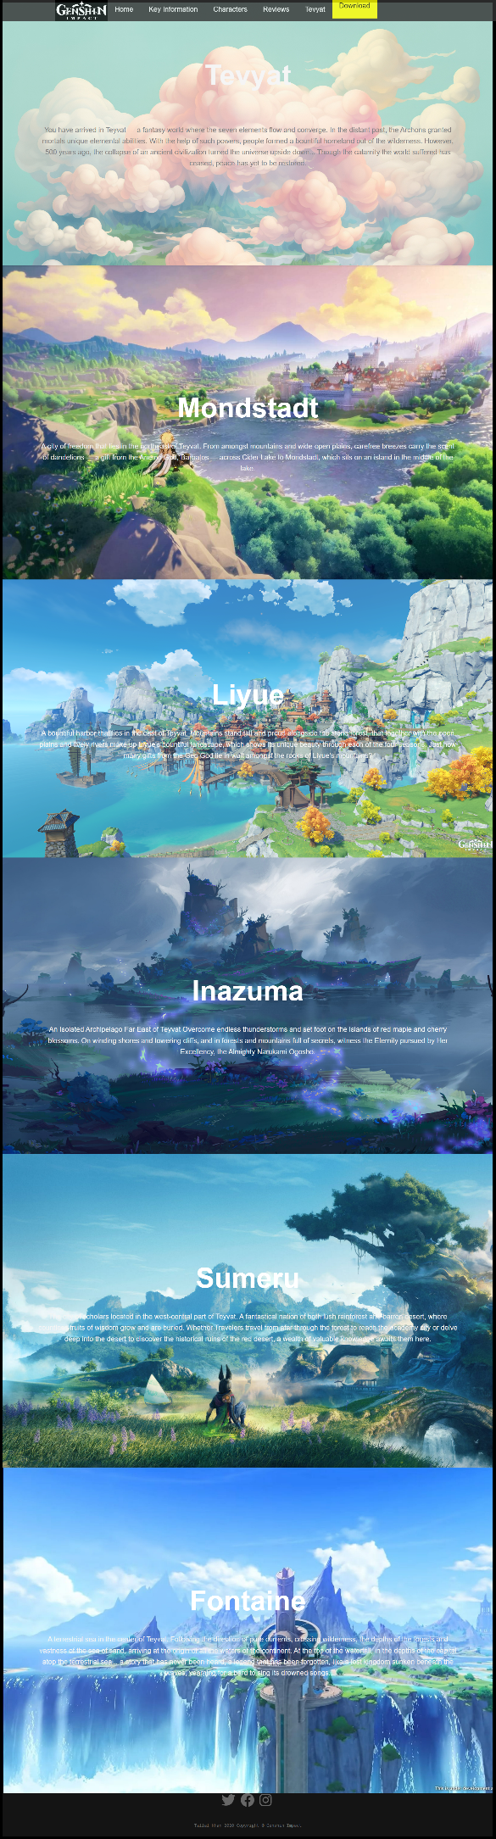

**Interaction Ovreview**

Interactivity is an important part of any good website and so I added a professional looking menu bar with the logo contained in it, the menu bar gives you the option to go to any of the five pages of the website and incorporates hover effects so that you know where your cursor is along with that it also has a download button which takes you to the download page for the game. There are also the images of the maps in the bottom of the home page which have hover effect and when clicked will take you to the specific description of the maps image you clicked on the Tevyat page which has information about the map, there is also linked buttons on the review page taking you to the website or to the YouTube video of the review.

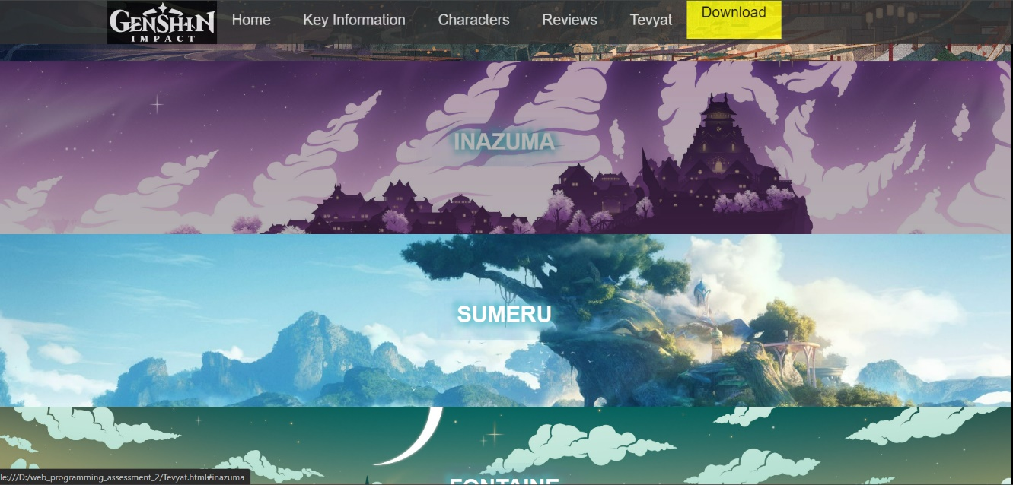

**Technical Description**

For coding the website, three different programming languages were used such as HTML, CSS, and Java Script. 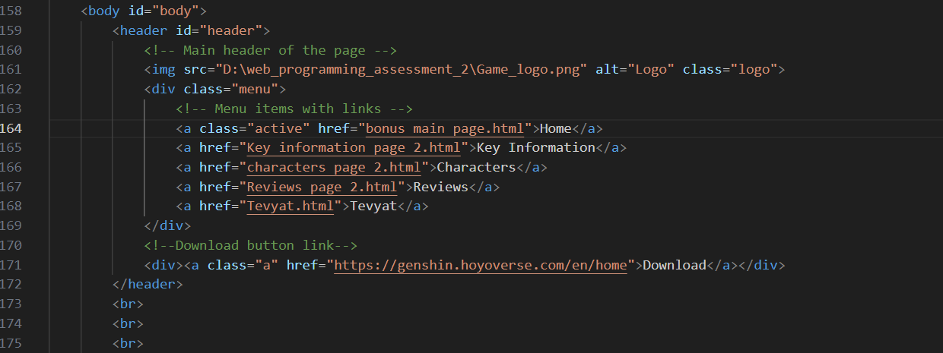The majority of the code was written in HTML and it was used to give the code a proper structure by separating the header the main content and the footer. Above, you can see that header was used to create a menu bar and was given its separate div tag to be able to freely style it using CSS.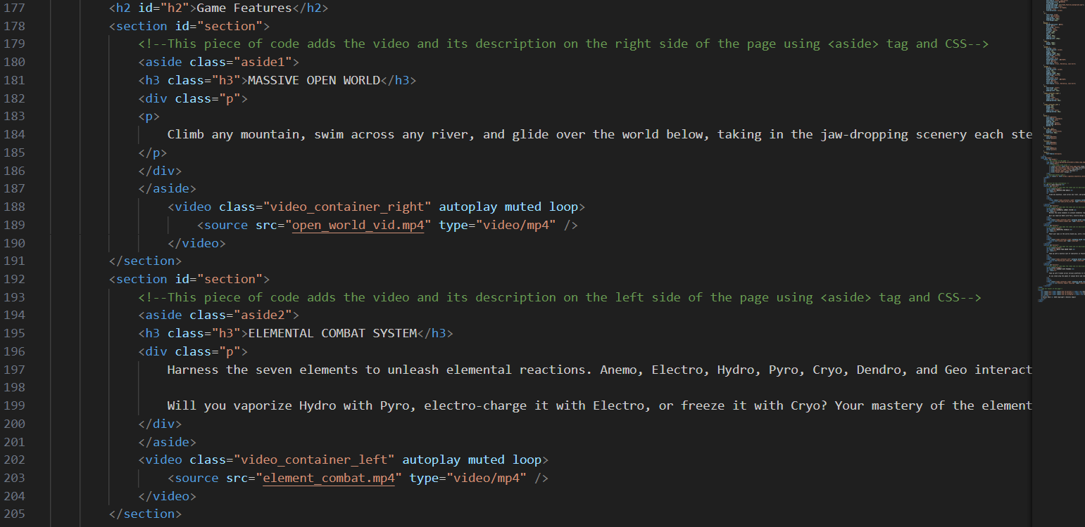

For the main body, HTML and its section tag was used to sperate the contents of the main body from each other, the code above is for the key information’s page in which inside the different section the video tag is used to add videos and control the video functionality such as auto play, muted, loop etc. also aside tag was used to add a description besides the video.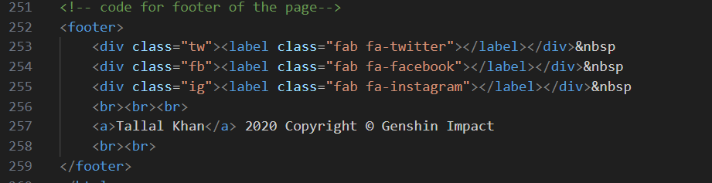

For the footer the footer tag was used and it contained the copyright information and the label tag was used to display label for twitter, Facebook and Instagram page which can be linked.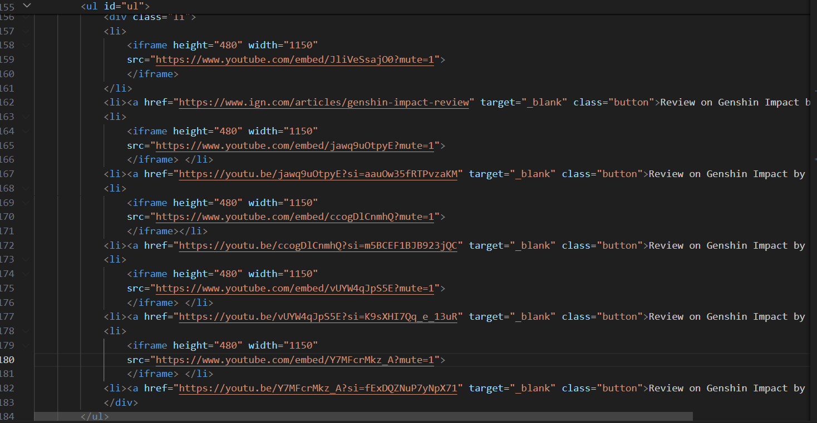

Aside from giving the code structure and proper separation, HTML tags such as Iframe and img tags were used to add videos and images to the website. The code above shows one of the places where I used iframe tags to embed video and also adjust their functionality by muting, auto playing or looping them also lists were used to arrange the videos and place them one by one.

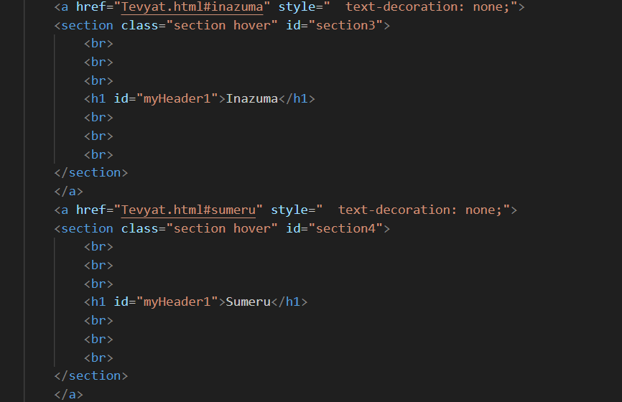

Html was not only used for structure but also to add a bit interactivity one such way is shown in my code here in which I linked the separate sections containing the header and background image to a separate Tevyat page which I made.

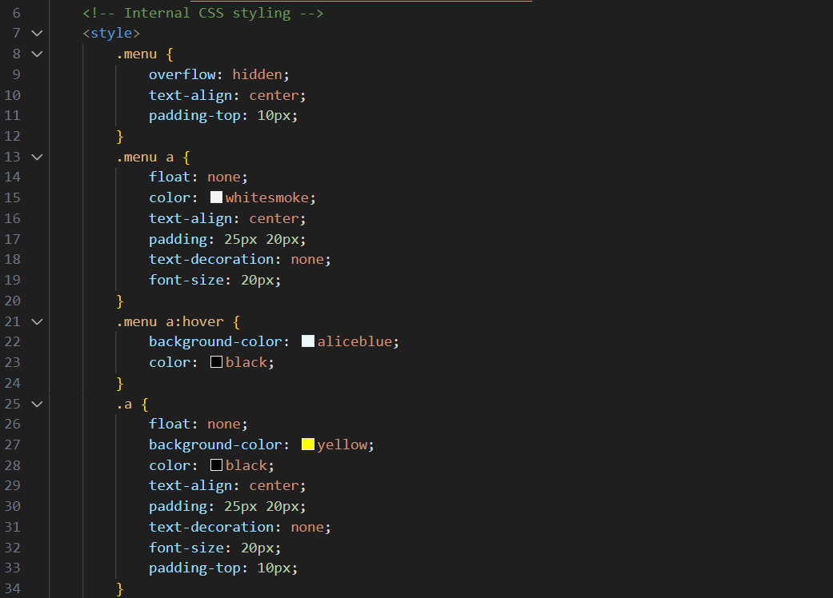

CSS was a huge part in designing and stylizing the website the code above is just a small portion of it. I used internal CSS styling for my website code and the code above is for the menu bar, I created different classes and stylized them according them to my needs and used either the class tag or the id tag in html to add my id and class CSS to the code. 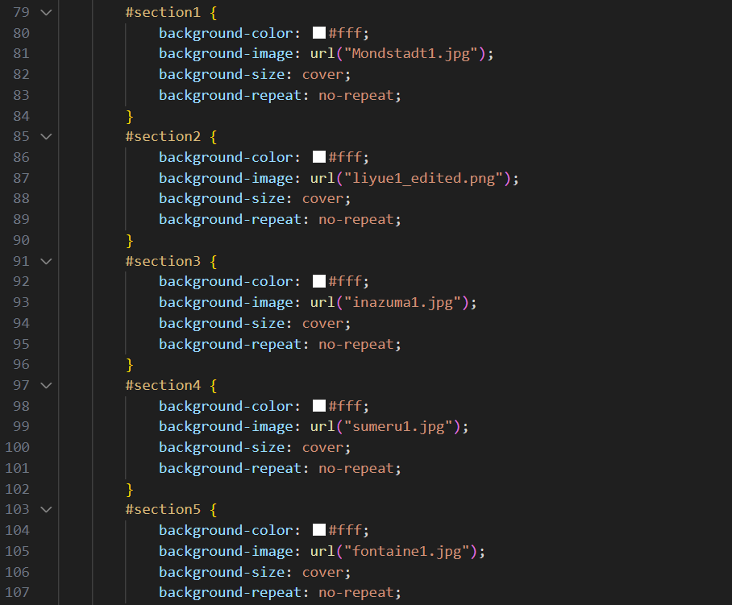



CSS was also used to stylize the different sections in the code like in the code above where each section is given a different background using background-image and each section is also given a hover effect.

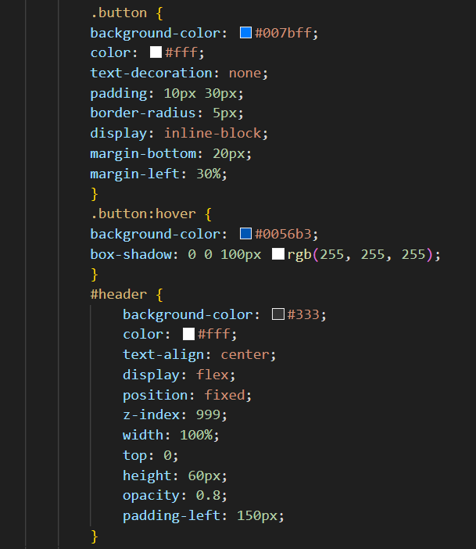

Buttons and their hover effect for the review page were also stylized using CSS.

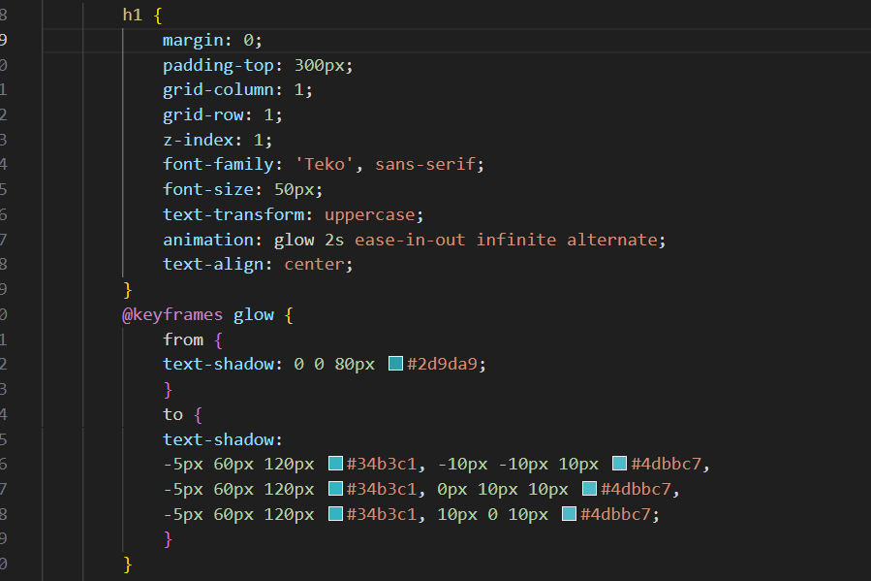



Java Script was used to add animation to a h1 tag to make it glow using @keyframes which allows text-shadow to be used to add that glowing effect also it was used to add font for the footer using script src.

**Critical Reflection**